Divergent Erudite Night

Objective: A Friday night youth group evening to explore the Erudite faction.

Teens are given a symbol (written in permanent ink) when they walk into the venue – using different maths symbols – ie, plus sign, equals sign, Pi sign, Multiplication sign. etc. This will determine the small groups starting with the first Activity.

Welcome to Erudite!
In a future world, war has caused incredible damage to the world.
People have been divided into five different factions focusing on different positive values.

Tonight we are focusing on the Erudite faction.

Who are the Erudite? Erudite are the faction known for their intelligence, research, and sharing of information.

Why Was Erudite Established? Erudite was formed by those who blamed ignorance for the war that occurred to eliminate ignorance and darkness from human minds.

What Do Erudite Value? They value knowledge, wisdom, intelligence, curiosity, reading and eloquence.

Erudite Night Rules
1. If you want to speak, put your hand up
2. You must appoint a group leader
3. Supervisor enforces order and submits scores
4. Repeat offenses will result in lowered grades
5. The winning group will be doubly rewarded!

Divide into small groups based on the symbols written on each teen’s hand.

Activity 1: Balancing Equations
Balance this equation: CaO + H₃PO₄ --> Ca₃(PO₄)₂ + H₂O

Here is the Solution: 3 CaO + 2 H3PO4 --> Ca3(PO4)2 + 3 H2O

Activity 2: History Quiz

Questions:

1. Where did the Renaissance start?
(a) Russia
(b) England
(c) France
(d) Italy

2. The discovery of sea-route from Europe to India was made by:
(a) Columbus
(b) Vasco-da-Gama
(c) Marco Polo
(d) Magellan
3. What was the name of the atom bomb dropped on Hiroshima during WW2?
(a) Little Boy
(b) Little Fly
(c) Little Devil
(d) None of these

4. What was considered the start of Jesus’ ministry?
(a) Wedding at Cana
(b) Baptism by John the Baptist
(c) Journey into the wilderness
(d) Journey to Jerusalem

5. Who was the disciple who replaced Judas?
(a) Justus
(b) Matthias
(c) Barsabbas
(d) Paul

6. How many books are there in the New Testament?
(a) 36
(b) 25
(c) 27
(d) 29

Answers:
1. The Renaissance started first in: (d) Italy
2. Who discovered the sea-route from Europe to India? (b) Vasco-da-Gama
3. What was the name of the atom bomb dropped on Hiroshima during WW2? (a) Little Boy
4. What was considered the start of Jesus’ ministry? (b) Baptism by John the Baptist
5. Who was the disciple who replaced Judas? (b) Matthias
6. How many books are there in the New Testament? (c) 27

Activity 3: Logic Puzzle
Five brothers, including Jake, have occupations in different cities. Who does what where?
Clues:
Travis is not a Carpenter nor Financial Advisor and does not work in Manchester.
Bob is the Bus conductor.
The Florist does not work in Liverpool.
Is Bill the TV Presenter?
The Financial Advisor works in London or Liverpool.
Bill works in Birmingham.
The Carpenter works in Swansea.
Simon works in London.

The Answers:
Name Occupation City
Bob Bus Conductor Manchester
Bill Florist Birmingham
Jake Carpenter Swansea
Simon Financial Advisor London
Travis TV Presenter Liverpool

Scoring: 1 Point for each correct row. 5 Extra for 100% right

Activity 4: Maths Equation
1. Solve for x: x + 144 = 256
2. Solve for x: 5^{x} = 2^{x}
3. Solve for x and y: x + y = 145 and x - y = 45
4. The sum of two consecutive number is 41. What are the numbers?

The Answers:
1. X = 112
2. X = 0
3. X = 95 and Y = 50
4. 20 and 21
Scoring: 1 Point for each

Activity 5: Bible Translation
Teens are given the following passage in Latin to translate into English:
et locutus ait sit nomen Domini benedictum a saeculo et usque in saeculum quia sapientia et fortitudo eius sunt
et ipse mutat tempora et aetates transfert regna atque constituit dat sapientiam sapientibus et scientiam intellegentibus disciplinam

Scoring: 1 Point for each key word they get correct – including wisdom, might, times, wisdom, knowledge, understanding.

Activity 6: Cell Structure – teens are given a 7 second view of the image on the following page and they have to build the cell structure out of the packet of licorice allsorts and toothpicks they are given.

Scoring:
1st place = 10 points
2nd place = 8 points
3rd place = 6 points

Activity 7: Word Definition
Find the definition of this word: Antidisestablishmentarianism

It defines a 19th-century British political movement that opposes proposals for the disestablishment of the Church of England.
Points will be awarded for:
Anti = against
Dis = negative
Establishment = founding
Ism = belief
Scoring: 1 Point for each word and Whole concept = 10 points

Activity 8: Brain Teaser – this activity is included if time allows or if there is a tie between two or more teams at the end of the previous 7 activities.

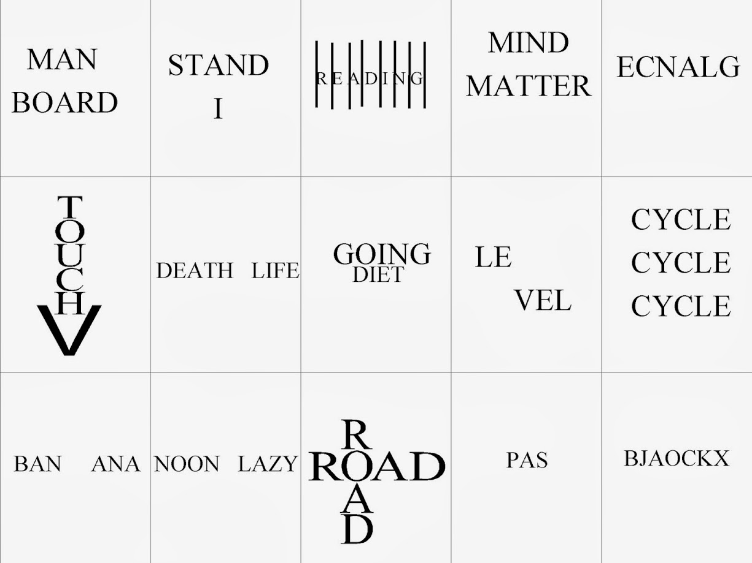

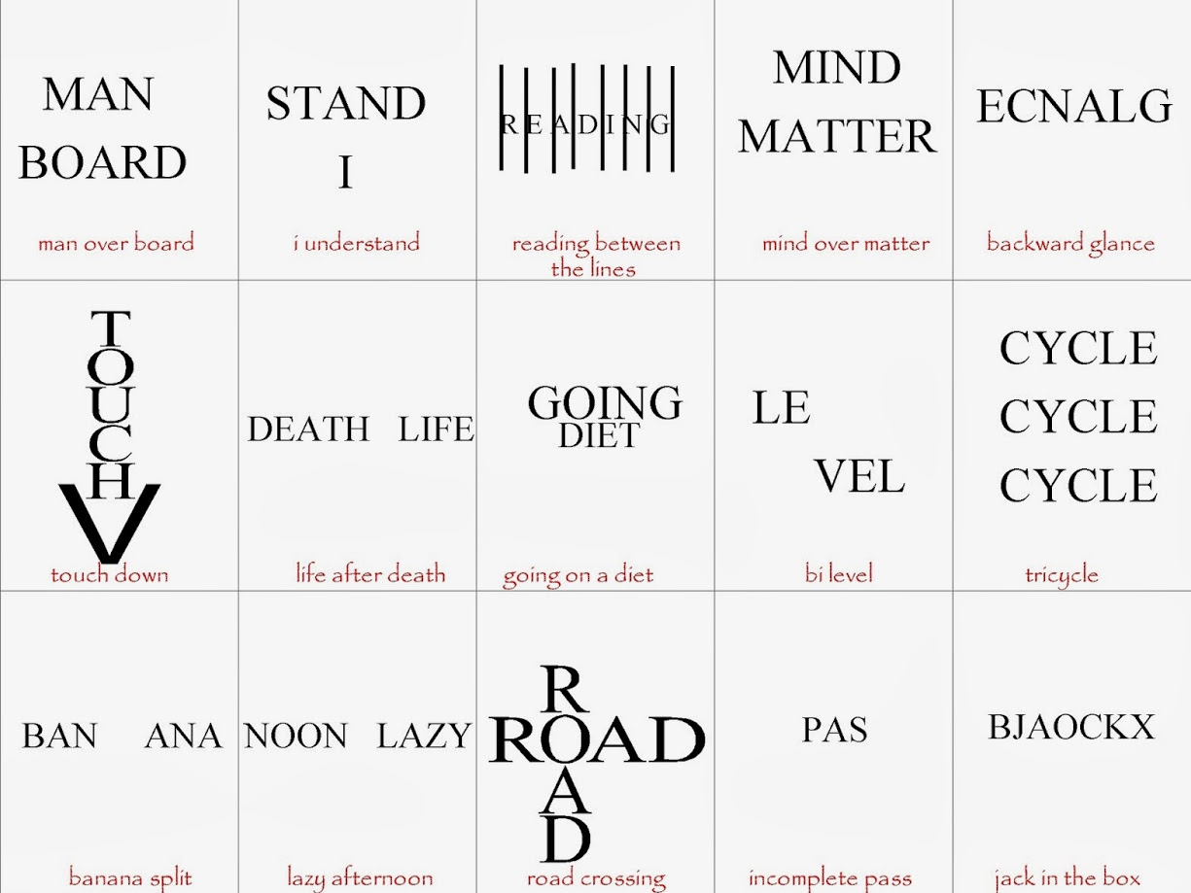

Congrats To The Winners! As winners you have won a two-part reward! Part 1: You now have control over everyone in the room as you are the smartest among us. Here is a list of five possible activities: choose one and everyone will be forced to obey it or become Factionless!

Choose from one of the following activities that the other groups have to complete:
1. Get into groups of 6 and create a human pyramid.
2. Play “Ring a Ring o’Roses” as a big group.
3. Form a giant group hug around Ps Mark and wish him happy birthday for Wednesday.
4. Play dead for a full minute.
5. Act like lunatics and jump on one leg around the room for a full minute.

Part 2: After small group time when the rest of the groups have their hot chocolate and a biscuit you are invited to a special celebratory experience on the stage in your honour!

Small Group Questions:
1. Which activities were easy tonight and which were hard for you?
2. What is the different between wisdom and knowledge?
3. What can you do practically to get wisdom using these tools? Listening, Reading, Questioning and Sharing
4. James 1:5 says we can ask God for wisdom. Spend time praying for each other to become wise.

