Fire Starters - Week 7

Welcome to another week in our Fire Starters series where we are learning how to become disciplemakers.

We have been learning how to Engage with our friends by using the SALT strategy: Start a Conversation, Ask Questions, Listen to their Story and Tell Your Story and Tell God’s Story.

This week we are going to get really practical and practise telling God’s story.

Video: Lecrae Gospel Rap in one minute. Get it on YouTube at: https://www.youtube.com/watch?v=Xt9VA3Cxdfo

As you listened to me telling you God’s story last week I am sure you must have had a few questions in your mind – like, How do I tell God’s story?

The Bridge to Life illustration. I am going to show you a way to tell God’s story just by using one Bible verse, a pen and a piece of paper. It is based on explaining Romans 6:23: “For the wages of sin is death, but the gift of God is eternal life in Christ Jesus our Lord.” I will show it to you and I also need someone to come up and draw it on the flip chart as we go along. Then I am going to let you guys practise it on a piece of paper and even share it with a friend. (Note: Tell the person drawing the illustration on the flip chart not to write the red words on the slides onto the chart!)

You start by writing Romans 6:23 on the top of the paper.

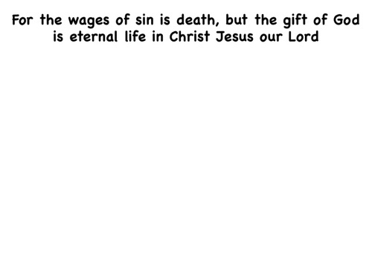

Next you write “MAN” on the left and ”GOD” on the right.

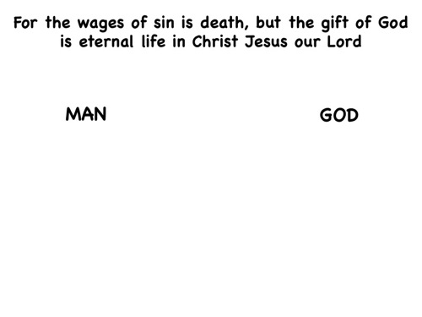

Draw a box around the word "WAGES", then write it in the block below the word man.
”What are wages?" (Wages are the reward we receive for what we have done.)
"How would you feel if your boss refused to pay you the wages that were due to you?
Deep down, we all know that it is only right that a person gets what he deserves.
We earn wages from God for how we have lived our lives."

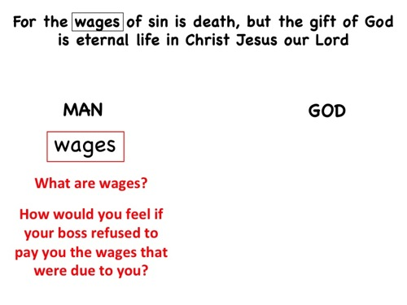

Draw a box around "SIN" in the verse and then write it below "WAGES.”
”What is sin?"
"How must a person live to get into heaven?”
“Have you always lived a life like you just described?"
(This should help him to see that even by his own definition he falls short of living a good and perfect life.)
"Sin is more an attitude than an action—it can be a hostile or apathetic response to God. At any point in your life, has God seemed far away?"

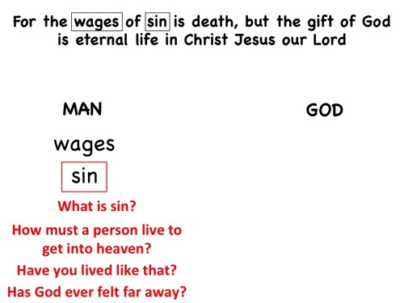

When he answers "yes," draw in the lines of the cliff on both sides and explain that sin has separated everyone from God.
"Imagine that you agreed with your roommate on rules regarding how to use your phone. What would happen if your roommate ignored the rules and broke your phone? Would that create a separation or problem in your relationship? Our sin creates a distance between us and God."

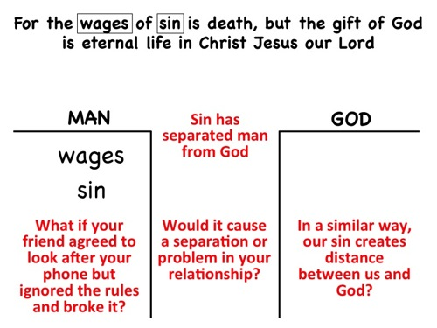

Draw a box around the word "DEATH," write it downbelow the word Sin.
"What thoughts come to mind when you think of death? Death often means separation—when we die our soul is separated from our body. If a person chooses to reject God while he is alive, that separation will extend into eternity: the separation will ultimately result in eternal torment in hell. Not only will he experience separation from God today, but also forever."

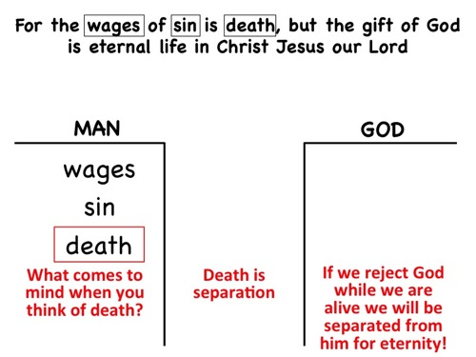

Draw a box around "BUT" in the verse and write BUT between the bases of the cliffs.
"This is the most important word in the verse because it indicates that there is hope for all of us. What we have talked about so far is bad news, but God has good news. What we're going to talk about now is a contrast to what we just discussed."
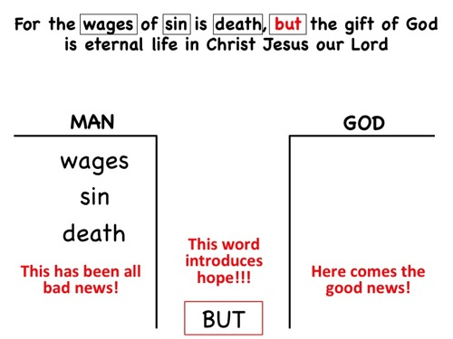

Draw a box around "GIFT" in the verse and write it on the right side of the cliff.
"What is the difference between a gift and wages?"
(From now on, be sure to point back and forth to each side of the cliff to emphasize that the words contrast with each other.)
"A gift is not earned by the person who receives it, but someone else pays for it. How do you feel towards someone who gives you an expensive gift?"
"Some people try to earn God's favor by doing good deeds, living moral lives, or taking part in religious activities. But it is impossible to earn something that has already been bought."
"Say you wanted to buy a special gift for a close friend to show how much that person means to you. How would you feel if the friend refused to accept it without first paying you for it?"

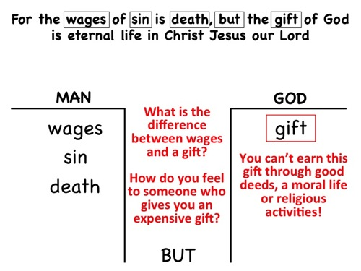

Draw a box around "OF GOD" and write it on the right side of the cliff, across from "SIN.”
Point to "SIN" on the left side and then back to "GOD" on the right and explain that all of us have sinned but God is perfect and has not.
"God wants to give you a gift. I can't give it to you; a church can't give it to you; no one can give you this gift but God alone. Why do you think God would want to give you a gift? Why does anyone want to give someone a precious gift?"

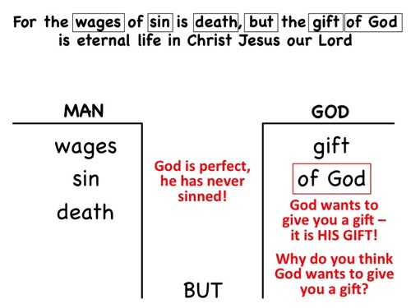

Draw a box around "ETERNAL LIFE" and write it on the right side of the cliff.
"What do you think eternal life is?"
Point to "DEATH" on the left side and show that "ETERNAL LIFE" is the opposite.
"Eternal life means a relationship with God in blissful harmony forever. Just as separation from God starts in this life and extends into eternity, eternal life starts now and goes on forever. No sin can end it."
(Ask if there is any part that you have explained so far that he does not understand or if he has any questions. Be sure that each point is clear before you proceed any further. If necessary, go back and explain each point that is not clear.)

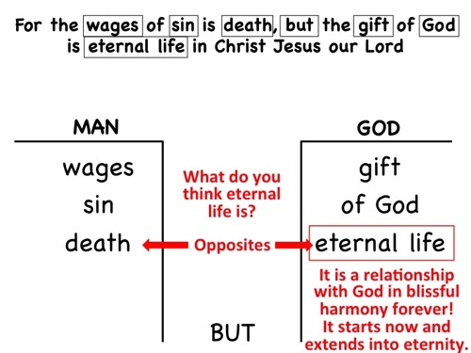

Draw a cross between the cliffs as a bridge. Box the words "CHRIST JESUS" in the verse. Write "CHRIST JESUS" inside the cross.
"Jesus is the means by which we can obtain the gift of eternal life. No one can offer a gift except the one who purchased it. He purchased it by paying for it with His life."
"Imagine that a police officer writes you a ticket for speeding and you go to court and the judge finds you guilty. But to your surprise, the policeman pays your fine out of his own pocket. In the same way, Jesus paid the fine for you—death."
Hold out a pen to the person, and ask him to imagine that someone had bought it for him as a present. As you hand it to him, ask him at what point the pen becomes his (when he accepts it). Tell him that he has to accept God's gift to him.
"A person is dying because his heart is diseased. Someone volunteers to donate his heart for a transplant, knowing that he will have to die in order to give it up. But first, in order to save his own life, the recipient must agree to accept the heart. It cannot be forced upon him."

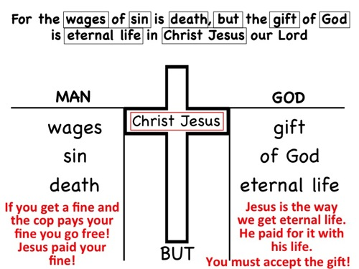

Finish off by drawing an arrow from the word MAN to the word GOD and talk about the need to confess our sins and surrender to Jesus as Lord so we can be saved. Becoming a follower of Jesus is all about trusting in Jesus to be our Lord and Saviour. Ask them where they are on the drawing – on which side of the chasm? If they would like to cross over then pray a prayer with the person where they can confess their sins and to invite Jesus to be their Lord and Saviour.

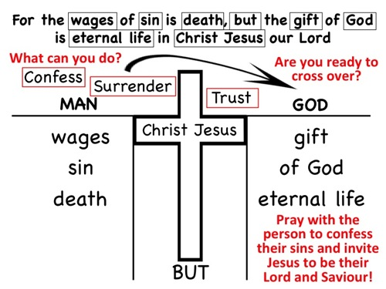

Handout: Each person will receive this handout so they can recall the various parts of the One Verse Bible presentation. It is available for download from: http://www.usna.edu/Navigators/_files/documents/OneVerse.pdf

Practise: Let’s practise by telling God’s story to the person next to you!

Challenge: The challenge for this week is to tell God’s story to at least one person.

Okay, I think I may know what some of you are thinking! I can read your mind…

God is so big, and I have many faults, and He is so perfect. Who am I to tell his story?

1. Have a close relationship with Him. Talk to Him, and he is sure to answer.

2. Yes we are not perfect, but God has chosen you to share His Good news.

Sharing God's truth with people can be intimidating, especially people you don't know very well.

But your desire to share your faith is really great. Many Christians don't have boldness in their witness for Christ, and you're taking the first step toward spiritual growth by wanting to share your faith.

The Bible teaches us that true believers want to share with others what God has done for them (John 4:28-30, John 4:39-42 )

Whether you're sharing with people you know or with total strangers, you need to live a consistent, Christ-centered life.

Nothing will kill your testimony faster than talking about Jesus with your lips and then denying Him with your actions. Simple consistency can sometimes do more than a sermon:

Simple consistency can sometimes do more than a sermon: You may not have an opportunity to tell the cashier at Woolworth about Jesus, but if you're polite and show some simple love and decency, the cashier will notice.

You'll stand out from the other customers who bark their orders and don't even mumble "thanks.”

Just being pleasant is often enough to make people scratch their heads and ask why. Then you have an open door to tell them what Jesus has done for you.

Evangelism is often about simply being a friend.

A lot of people in this world need love and compassion. They've had tough days: failing tests, fighting parents, and crashing relationships. They could use a friend and a good listener. Jesus often spent time just being with people and listening to them.

Love is not arrogant and preachy. It's not rude and demanding. Love is compassionate and caring. It's patient and kind (read 1 Corinthians 13:4-7).

Above all, remember to pray.
Pray that the Holy Spirit will give you opportunities to tell others about Christ.
Pray that the Holy Spirit will let others see your Christ-like example, even when you don't say a word.
Pray daily for friends and family that need Christ, as well as people you don't know very well, and even pray for passing strangers.
Ask God for wisdom to share the most important thing in your life with these people (James 1:5 and James 3:17).

In week 8 you will learn how to release God encounters in your disciplemaking.

