Performance Measurement in Ministry
A Paper by Mark Tittley, Director of Sonlife Africa presented at GYI 2006 in Malaysia

Introduction
During 2004, Sonlife Africa experienced a staffing crisis and a phase of explosive growth through the efforts of regional directors in Southern, Central and West Africa. This meant that the time was right to clarify our strategy and improve our measurement of performance. A consultant from Accenture, Steven Smith, introduced the organisation to the Balanced Scorecard and within two weeks our first prototype scorecard was completed. It took a number of revisions over the next nine months before the Board took ownership of the tool as our performance management system.

1. The Balanced Scorecard
The origins of the Balanced Scorecard can be traced back to 1990 when the Nolan Norton Institute sponsored a one-year multi-company study entitled: “Measuring Performance in the Organization of the Future.” The study participants (Nolan Norton and Robert Kaplan) believed that reliance on measuring financial performance hinders the ability of organisations to create economic value.

Kaplan and Norton introduced the Balanced Scorecard in 1992 as a business performance system designed to implement organisational strategy. The scorecard uses the process of setting specific and challenging goals (beyond the traditional financial focus) that translate an organisation's mission and strategy into a comprehensive set of performance measures. It is called the Balanced Scorecard because:

* It is balanced: An organisation should focus on more than financial objectives and indicators. It balances financial and non-financial measures. It balances internal (internal business processes) and external (shareholders or trustees) constituents of the organisation. It balances lagging (past performance) and leading (future drivers of performance) measures of performance.

* It is a scorecard: Much like a cricket scorecard shows how you are doing against the other team, the BSC shows how you are doing against targets you choose, dependant on your strategy.

The Balanced Scorecard does not exist in a vacuum – it is part of the overall strategic plan:

Kaplan and Norton have identified five basic principles to align and focus every process and system within the organisation to match with its overall strategy:
(1) Translate the Strategy into Operational Terms – everyone must understand the strategy of the organisation so it is presented in a cause and effect linkage that reveal how the strategy will be implemented.
(2) Align the Organisation to the Strategy – to create synergy within the organisation the activities of the independent work units must be aligned and integrated.
(3) Make Strategy Everyone's Everyday Job – for an organisations’ strategy to be successful, everyone must be working towards it in their day-to-day jobs. Everyone must know their role within the strategy and how they can help the organisation achieve positive results.
(4) Make Strategy a Continual Process – Organisations must be able to adapt their strategies as the world changes or the strategy matures – so everyone must be linked to the strategy to create a healthy environment for open communication.
(5) Mobilize Leadership for Change – the executive team must convince everyone in the organisation that the change is a good idea and keep the strategy in front of people at all times.

2. The Components of the Balanced Scorecard
The BSC is an approach that seeks to align four perspectives to create a balanced measurement system to achieve the organisational strategy – with each perspective fleshed out through objectives, measures, targets and initiatives.

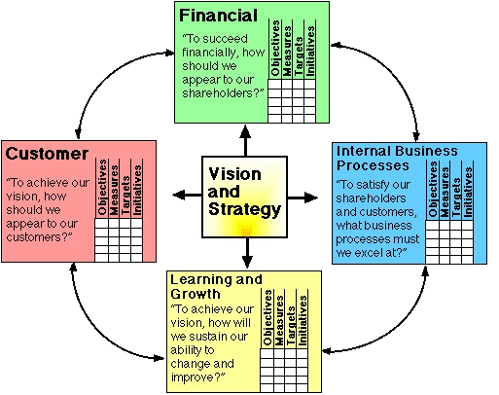

A. Vision, Values and Mission
The organisation must clearly articulate their mission, values and vision before attempting to develop a balanced scorecard. This big picture focus provides the context in which the strategy will be developed.

B. Perspectives
Every organisation has a strategy for how it plans on creating value for its customers, shareholders and stakeholders. Numerous approaches have been developed on how best to describe and fine-tune strategy to enhance the creation of value. The Balanced Scorecard approach suggests that an organisation’s ability to create value in the future will be driven by four key factors or perspectives:

(1) The Organisational Learning and Growth Perspective – how intangible assets are being improved so as to create a learning organisation that grows in effectiveness. There are three categories of intangible assets: (a) Human capital – your people; (b) Information capital – what you know; and (c) Organisational capital – how you operate.

(2) The Internal Business Processes Perspective – the various internal processes by which products and services are prepared and delivered to customers. These are four categories of internal processes: (a) Operations management – producing and delivering; (b) Customer management – relationship building; (c) Innovation – next generation products or services; and (d) Regulatory and social – complying with the law.

(3) The Customer Perspective – what specific and differentiated value proposition the organisation is providing its customers – ie. That which distinguishes the organisation from competitors. There are four major value propositions: (a) Lowest total cost of ownership; (b) Superior products or services; (c) Complete customer solutions; and (d) System lock-in to make switching difficult.

(4) The Financial Perspective – what financial results will be required to appear to be successful to its shareholders. This will be a balance between investing for long-term growth and cutting costs for short-term results.

C. Objectives
Objectives are those key outcomes that the organisation needs to reach to accomplish its strategy – they are identified in each of the four perspectives respectively.

D. Metrics
These are actionable and tangible measurements that support achieving objectives – this is what makes the scorecard real and measurable.

E. Targets
Performance level expectations are then set against the strategic plan. For each metric, a goal is set or a plan developed so that progress for each objective can be evaluated.

F. Initiatives
These are specific and actionable items that can be executed by individuals within the organisation.

G. Strategy Map
The Strategy Map is a one-page graphical representation of an organisations' strategy. It includes the mission, perspectives, objectives, metrics and targets. The strategy map is also referred to as a “cause-and-effect'” or linkage diagram. Cause and effect linkages in strategy maps are like “if-then” statements (for example, if we increase customer loyalty then revenue will increase).

H. Dashboard
A dashboard is an easily understood set of measures that communicates visually using charts and gauges. It can be created within MS Excel or PowerPoint or Scorecarding software can be purchased to automate the dashboard. A dashboard is a great help in communicating your strategy.

3. The Balanced Scorecard in Non-Profit Organisations
Financial success is not the primary objective of a non-profit organisation so it is necessary to modify the architecture of the Balanced Scorecard. Financial indicators are not the relevant indicators of whether the agency is delivering on its mission. The mission should be featured at the highest level in the scorecard. It is best to place the customer and stakeholders at the top of the scorecard (beneath the mission) and develop objectives for donors and customers and then identify internal business processes that will deliver the desired value propositions for both these groups.

Mission

If we succeed, how will be look to our financial donors?
To achieve our vision, how must we look to our customers?

To satisfy our customers, financial donors and mission, what business processes must we excel at?

To achieve our vision, how must our people learn, communicate and work together?

4. Sonlife Africa and the Balanced Scorecard
In order to provide an example of how to develop a balanced scorecard, we will explore the Sonlife Africa balanced scorecard:

A. Mission
Sonlife Africa exists to establish church-based disciplemaking youth ministry in each country in Africa to help fulfil the Great Commission.

B. Values
We value the church as the hope of the world, the life and ministry of Christ as the model for ministry, the ability of young leaders to develop ministries in local churches that demonstrate the priorities of disciplemaking (winning, building, equipping and multiplying), and the empowerment of servant leaders passionate about the Great Commission and the Great Commandment.

C. Vision
We will achieve our mission by training, coaching and mentoring young leaders in each country in Africa to develop disciplemaking youth ministries that grow healthy churches and start a disciplemaking movement that covers each country.

D. Strategy
The strategic process of Sonlife Africa is as follows:
(1) Raise funds and control expenses
(2) Develop corporate structure, evaluating knowledge and develop training material
(3) Mobilise country and regional leaders to oversee the presenters
(4) Empower presenters to train, coach and mentor key leaders
(5) Prepare key leaders in local churches to implement disciplemaking ministries
(6) Develop healthy disciplemaking ministries in local churches

E. Strategy Map
This process is represented in the following Strategy Map that is read from bottom to top:

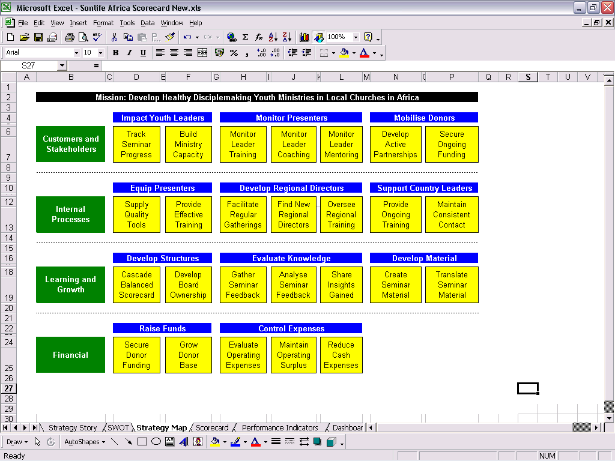

F. Perspective Measures
The following chart shows how the Internal Processes perspective is fleshed:

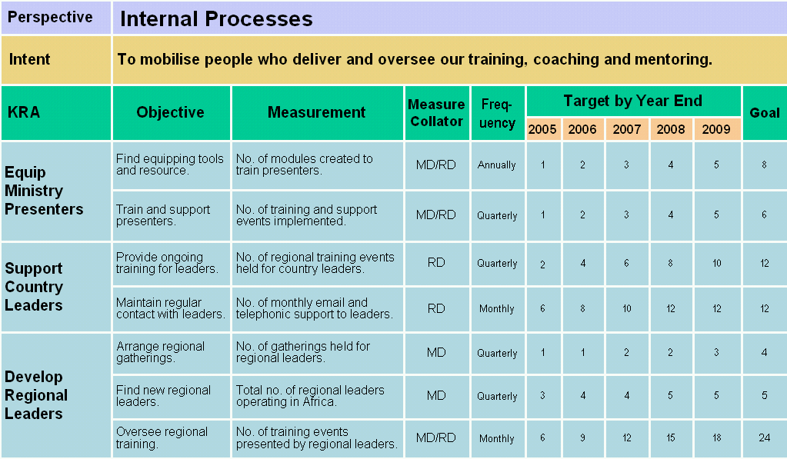

The measure collator is the person responsible to keep a check on that item (for us, MD is managing director and RD is regional director); the frequency is how often it is reviewed.

G. Dashboard
Here is the Sonlife Africa dashboard that enables us to at a glance check on our progress:

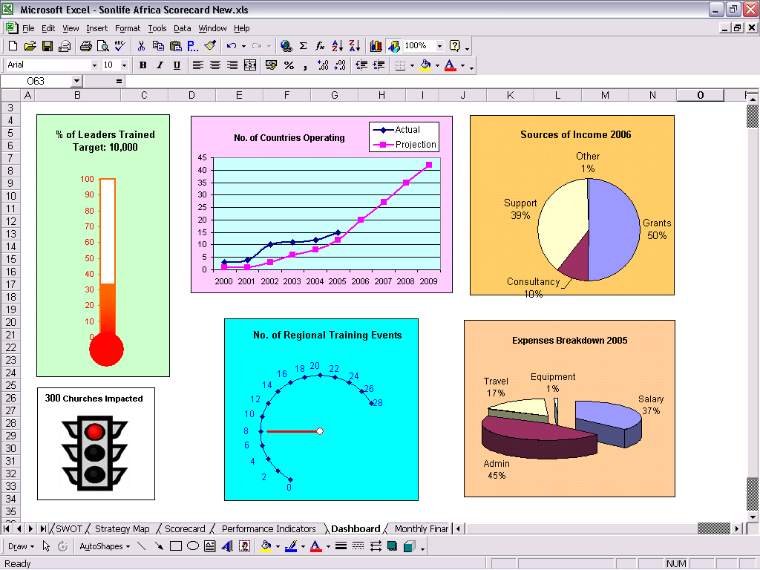

H. RACI Charting
A recent development linked to the balanced scorecard is that of Roles and Responsibilities Charting (RACI) that is a technique used to identify activities and the individuals or groups involved in them activities or decisions. It answers the questions: (1) What has to be done? (2) Who must do it?

RACI is an acronym that stands for:
(1) Responsible – The person who has to do the work.
(2) Accountable – The person who has to make sure the work gets done.
(3) Consulted – The person who must be consulted before the work is started.
(4) Informed – The person who must be informed after the work has been completed.

The following guidelines are essential to effective RACI charting:
(1) The team leader must own the RACI chart.
(2) One person, or a team, must be accountable for each task.
(3) Give authority with accountability to empower people to act.
(4) Place accountability and responsibility at the lowest possible level.
(5) Minimise the number of people consulted and informed.
(6) Document and communicate all roles and responsibilities.

Here is an example of how our Internal Process perspective is fleshed out with roles and responsibilities assigned to each measure:

Internal Process Perspective

KRA: Equip Ministry Presenters | MD | RD | CL | BC | FD | BM | ID
Find tools and resource to equip presenters | A | R | R | I | I | I | I
Train and support presenters | A | R | R | I | I | I | I

KRA: Support Country Leaders | MD | RD | CL | BC | FD | BM | ID
Provide ongoing training for leaders | A | R | R | I | I | I | I
Main regular contact with leaders | A | R | R | I | I | I | I

KRA: Develop Regional Leaders | MD | RD | CL | BC | FD | BM | ID
Arrange regional director gatherings | R | C | - | A | A | I | I
Find new regional directors | R | C | C | C | C | C | C
Oversee regional training | A | R | R | C | I | I | I

Key to Table:
MD – Managing Director R – Person Responsible
RD – Regional Directors A – Person Accountable
CL – Country Leaders C – Person Consulted
BC – Board Chairman I – Person Informed
FD – Financial Director
BM – Board Members
ID – International Director

5. Implementing the Balanced Scorecard
The ingredients to successful implementation of a Balanced Scorecard are:

A. Provide leadership from the top
Senior management or leaders must create the climate for change – they are critical to the success of the whole performance management process.

B. Make strategy everyone's job
Communication must be comprehensive - everyone must know and understand their role in the execution of the strategy. Goals, and the incentives established to achieve them, must be aligned.

C. Unlock and focus hidden assets
Work processes are reengineered to make the most of people's energies, talents, and training. We must create knowledge sharing networks – organisation-wide cross-functional communication.

D. Make strategy a continuous process
Strategic feedback must be non-blaming and designed to encourage learning: Mistakes are identified and learned from and hypotheses are tested. Learning is like breathing – it is non-stop and vital to the life of the organisation.

6. Recommended Reading
Books by Robert S. Kaplan and David P. Norton:
(1) The Balanced Scorecard: Translating Strategy into Action
(2) The Strategy-focused Organisation
(3) Strategy Maps: Converting Intangible Assets into Tangible Outcomes

