Understanding Yourself
And Leading People

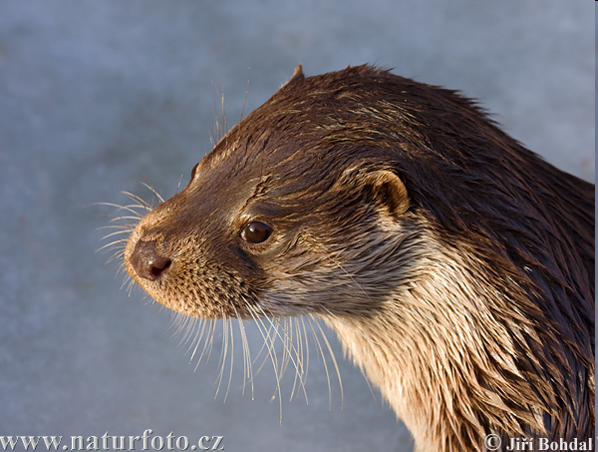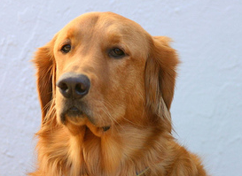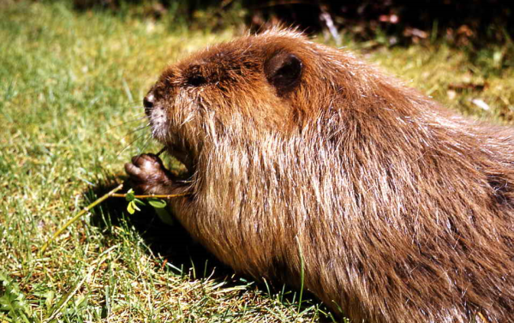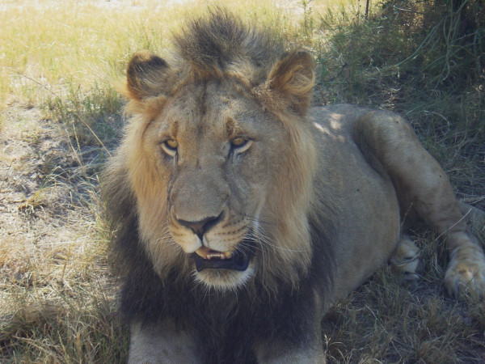

Presented by Pastor Mark Tittley
At His People Christian Church

1. The Animal School

It wasn't too long after creation when the animals got together to form a school. They wanted the best school possible, offering their students a well rounded curriculum of swimming, running, climbing and flying. In order to graduate, all the animals had to take all the courses. The duck was excellent at swimming. In fact, he was better than his instructor. But he was only making passing grades at climbing and was getting a very poor grade in running. The duck was so slow in running he had to stay after school every day to practice. There was only a little improvement, because his webbed feet got so badly worn. With such worn feet, he was only able to get an average grade in swimming, but average was quite acceptable to everyone, so no one worried much about it...except the duck. The rabbit was at the top of her class in running. But after a while, she developed a twitch in her leg from all the time she spent in the water trying to improve her swimming. The squirrel was a peak performer in climbing, but was constantly frustrated in flying class. His body became so bruised from all the hard landings he had, he did not do too well in climbing and ended up being pretty poor in running. The eagle was a continual problem student. She was severely disciplined for being a nonconformist. For example, in climbing class, she would always beat everyone else to the top of the tree, but insisted on using her own way to get there.

What’s the message of the story?

Each of the animals had a particular expertise. When they did what they were designed to do, they excelled. When they tried to operate outside their area of expertise, they were not nearly as effective.

Can ducks run? Sure they can! Is that what they do best? No! Many schools are full of running ducks. People who are trying to do the best they can, but they are doing things they are not gifted to do. We need to get the ducks in the water, the squirrels in the trees and the birds in the air. Everyone can become peak performers in their areas of expertise. God has given spiritual gifts and natural talents to each person.

We do well when we:
* Know and operate within our strengths and weaknesses
* Work together with others to accomplish a common goal
* Bring our unique strengths to a team or leadership position
* Be ourselves and not someone else

2. What Determines My Personality?

A. Pace - Pace is the speed at which I move through life – the speed of my actions.

B. Priority - Priority is the focus of my life – the motivation behind my actions.

The Task personality is focussed on getting things done while the People personality is focussed on hanging out with people.

Pace is all about my internal motor (like the accelerator in a car) while Priority is my internal compass (like the steering wheel in a car).

These two qualities can produce conflict between people:
In the Bible (Acts 15:36-41) two close friends (Paul and Barnabas) found themselves in a conflict situation. It was so strong that they had to separate and go in different directions. A young man (John Mark) had deserted Paul and Barnabas on a previous mission trip. Barnabas said: “Let’s give John Mark another chance and take him along with us” while Paul said: “No ways! The work is too important to risk taking someone along with a bad track record”. So the two men went their separate ways: Paul sailed off with Silas while Barnabas took John Mark under his wings. Each man had different priorities and God’s work was accomplished and later John Mark was restored.

Who was right? If you are more people-focussed you will agree with Barnabas but if you are more task-focussed you will agree with Paul. Both sides are needed! Someone needed to focus on the work and make sure that it was successful, and someone needed to focus on restoring the wounded person.

3. How do Pace and Priority Create My Personality Type?
The two strands of fast/slow pace and task/people priority combine to form different personality styles.

4. How Can I Discover My Personality Type?
Here is a small test to take to find out what your personality is. In each box chose the words that best describe your personality. Double the number of words you chose and fill in that number.

The Lion |  | The Otter
Likes authority  Confident  Firm  Enjoys challenges  Problem solver  Bold  Goal driven  Strong willed  Self reliant  Persistent | Takes charge  Determined  Enterprising  Competitive  Productive  Purposeful  Adventurous  Independent  Controlling  Action oriented | Enthusiastic  Visionary  Energetic  Promoter  Mixes easily  Fun-loving  Spontaneous  Creative-new ideas  Optimistic  Infectious laughter | Takes Risks  Motivator  Very verbal  Friendly  Enjoys popularity  Likes variety  Enjoys change  Group oriented  Initiator  Inspirational
Double the number chosen: ___ |  | Double the number chosen: ___
The Beaver |  | The Retriever
Enjoys instructions  Consistent  Reserved  Practical  Factual  Perfectionistic  Detailed  Inquisitive  Persistent  Sensitive | Accurate  Controlled  Predictable  Orderly  Conscientious  Discerning  Analytical  Precise  Scheduled  Deliberate | Sensitive feelings  Calm  Non-demanding  Avoids confrontation  Enjoys routine  Warm and relational  Adaptable  Thoughtful  Patient  Good listener | Loyal  Even tempered  Gives in easily  Indecisive  Dislikes change  Dry humor  Sympathetic  Nurturing  Tolerant  Peacemaker
Double the number chosen: ___ |  | Double the number chosen: ___

Transfer your scores to this chart and connect the four dots:

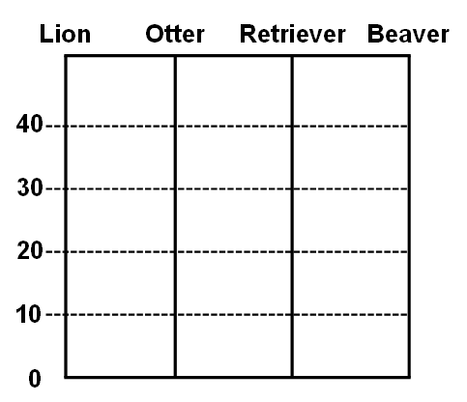

My Primary Personality Type is
5. What is the Difference Between the Four Personality Types?
Here is a description of the four personality types:

A. The Lion - This personality likes to lead. The lion is good at making decisions and is very goal-oriented. They enjoy challenges, difficult assignments, and opportunity for advancement. Because lions are thinking of the goal, they can step on people to reach it. Lions can be very aggressive and competitive. Lions must learn not to be too bossy or to take charge in other's affairs.
* Strength: Goal-oriented. Strong. Direct.
* Weakness: Argumentative. Dictating.
* Limitation: Can hurt others with directness. Battles to express grace.

B. The Otter - Otters are very social creature. They enjoy being popular and influencing and motivating others. Otters get hurt when people do not like them. They usually have lots of friends, but not deep relationships. They often have messy rooms. Otters like to quickly finish jobs – so don’t always do a good job.
* Strength: People Person. Open. Positive.
* Weakness: Talk too much. Too permissive.
* Limitation: Remembering past commitments. Follow through with discipline.

C. The Retriever - Good at making friends. Very loyal. Retriever personalities do not like change. They look for security. They can be very sensitive. Very caring. Have deep relationships but usually only a couple of close friends. Want to be loved by everyone. They look for appreciation.
* Strength: Accommodating. Calm. Affirming.
* Weakness: Indecisive. Unable to express emotions. Too soft on people.
* Limitation: Seeing the need to be more assertive. Holding others accountable.

4. The Beaver – Beavers are organized. They think there is a right way to do everything and they want to do it exactly that way. They are very creative. They desire to solve everything. They take their time to do things right. They do not like sudden change. They need reassurance.
* Strength: High standards. Order. Respect.
* Weakness: Unrealistic expectations of self and others. Too perfect.
* Limitation: Seeing the optimistic side of things. Expressing flexibility.

6. How Do I Lead With My Personality Type?

Circle the words that match your primary style:

STYLE | Lion (D) | Otter (I) | Retriever (S) | Beaver (C)
Preferred Tasks | Challenging | People related | Scheduled | Detailed
Leadership Style | Decisive | Interactive | Cooperative | Traditional
Strength | Problem Solver | Encourager | Supporter | Organiser
Weakness | Too direct | Too disorganised | Too indecisive | Too detailed

MY LEADERSHIP STYLE

I prefer tasks that are ___________________________________________________________________.

As a leader I am _______________________________________________________________________.

My strengths as a leader is _______________________________________________________________.

My weakness as a leader is ______________________________________________________________.

7. What Are My Personality Types Weaknesses?

The Lion: Abuse position, set too high standards, speaks harshly, takes on too much too fast.

The Otter: Inattention to detail, unrealistic views of people, trusts too easily.

The Retriever: Gives in to stop conflict, battles to set priorities, dislikes change.

The Beaver: Defensive when criticised, gets bogged down in details, too intense, too cool.

8. How Do Great Leaders Relate to People?
They respond to people depending on what personality style they have. Here are two examples:

A. God related to Moses and Paul differently:

To get Moses’ attention (he was a Beaver) God used a small flickering light on a mountainside – Moses was curious and went to investigate things. God explained things in detail to him (Exodus 3). God patiently answered all his questions.

To get Paul’s attention (he was a Lion) God blinded him with such a bright light that it knocked him to the ground. God used direct confrontation with Paul. A soft approach would not have worked with him.

B. Jesus related to Martha and Mary differently:
In John chapter 11, when Jesus arrived too late to heal Lazarus and both Mary and Martha accused Jesus of being too late to help.

With Martha (she was a Lion) when she went running out to meet Jesus and accused him of not caring, Jesus reasoned with her and confronted her.

With Mary (she was a Retriever) when she stayed in the house and later met Jesus and accused him of not caring, Jesus showed her compassion.

Martha (the Lion) needed to be challenged while Mary (the Retriever) needed to be comforted.

9. How Do We Identify The Personality Type of People We Are Leading?
Use the following questions:
(1) Are they Fast or Slow Paced?
(2) Are they Tasks or People focussed?
(3) Which quadrant do they fall into?
(4) What is their personality type?

10. Some Deeper Insights into Personality Types

 | Lion (D) | Otter (I) | Retriever (S) | Beaver (C)
My ideal world is when I have ________. | Control | Fun | Peace | Perfection
I like to ________ things. | Change | Dream | Watch | Research
I want to do it _______ way. | My | The Exciting | The Easy | The Right
To convince me, I need to know ________. | What | Who | Why | How
My greatest fear is losing ________. | Control | Face | Stability | Structure
My leadership strength is ________. | Taking  Initiative | Influencing  Others | Implementing  Plans | Being  Excellent
I tend to lead through ________. | Force | Speaking | Relationship | Rules

