Hiding, Hurling or Helping

The account of Adam and Eve’s first days are recorded for us in the first book of the Bible, Genesis. God first created an environment in which they could live. It was the most beautiful garden we could ever imagine. Animals roamed freely and probably lived in harmony with one another. I guess we would call it Paradise!

For five days he worked - speaking everything into existence. And then on the sixth day he played his trump card as he created a male and female and placed them in the garden. Genesis 1:26-28.

They had unlimited access to God. They could probably communicate with him face to face at any time of the day and it seems like there was a regular meeting together in the cool of the day during the late afternoon. Genesis 3:8a.

They had open communication with each other. There was dignity and respect shown to each other. They enjoyed an open and transparent relationship. Together they named all the animals and together they cared for the garden that they had been placed in. Genesis 2:15-18,25.

Truly they had Found Paradise!

But the story includes a dark chapter, one day they decided to disobey God - they wilfully chose to violate the only command that he had given them for continued existence in Paradise. They allowed Satan to tempt them to doubt God’s words and to disobey his command not to eat from the tree of the knowledge of good and evil. Genesis 3:1-7.

Suddenly they had Lost Paradise!

Their relationship with God was shattered. Sin had come in between their relationship with God - to the extent that when God arrived for his afternoon time of intimacy with them, he had to play a game of hide-and-go-seek to find them. Geness 3:8b

They relationship with each other was broken. They were now aware of their nakedness and found it necessary to hide from each other by covering themselves with leaves. A desparate attempt to hide from each other and from their Creator.

When God eventually found them they did not come clean about what they had done, but tried to shift the blame. Adam blamed God for having put Eve in the garden in the first place and he blamed Eve for giving him the fruit to eat. Eve blamed the serpent who had given her the crazy idea to eat the fruit and we all know that the snake did not have a leg to stand on.

God, being just, had to read them the sentence they had received for the crime that they had committed. They would find it difficult to make ends meet on the earth, they would struggle with each other and most tragically they would have to leave the garden - paradise was indeed lost. The way back into the garden was blocked by a fiery angel with a drawn sword.

What does this story have to do with you starting at Baptist College in the year 2000?

It warns us about two dangers:

1. Losing Touch with God (Hiding)
What will make you lose touch with God?
Sin, Busyness, Broken Relationships

What will help you to stay in touch with God?
Develop Spiritual Disciplines - daily devotions, fasting,
Practise the Presence of God - don’t compartmentalise God into chapel periods - open up a continual dialogue with God (OH8,9)

Involve the audience - what are the ways in which we can stay connected with God?

2. Falling Out With Each Other (Hurling)
Believe it or not, loving, open and honest relationships will not always be easy to find during your time at College.

What will make us fall out of relationship with each other?
Pride - causes us to hide from each other and to hurl at each other

What will help to ensure that our relationships are evidenced by openness and honesty?
Humility, Respect, Gentleness, Encouragement

Reflect on: Ephesians 4:29 “Do not let any unwholesome talk come out of your mouths, but only what is helpful for building others up according to their needs, that it may benefit those who listen.”

HELPING

Do not let any unwholesome talk come out of your mouths, but only what is helpful for building others up according to their needs, that it may benefit those who listen.
Ephesians 4:29

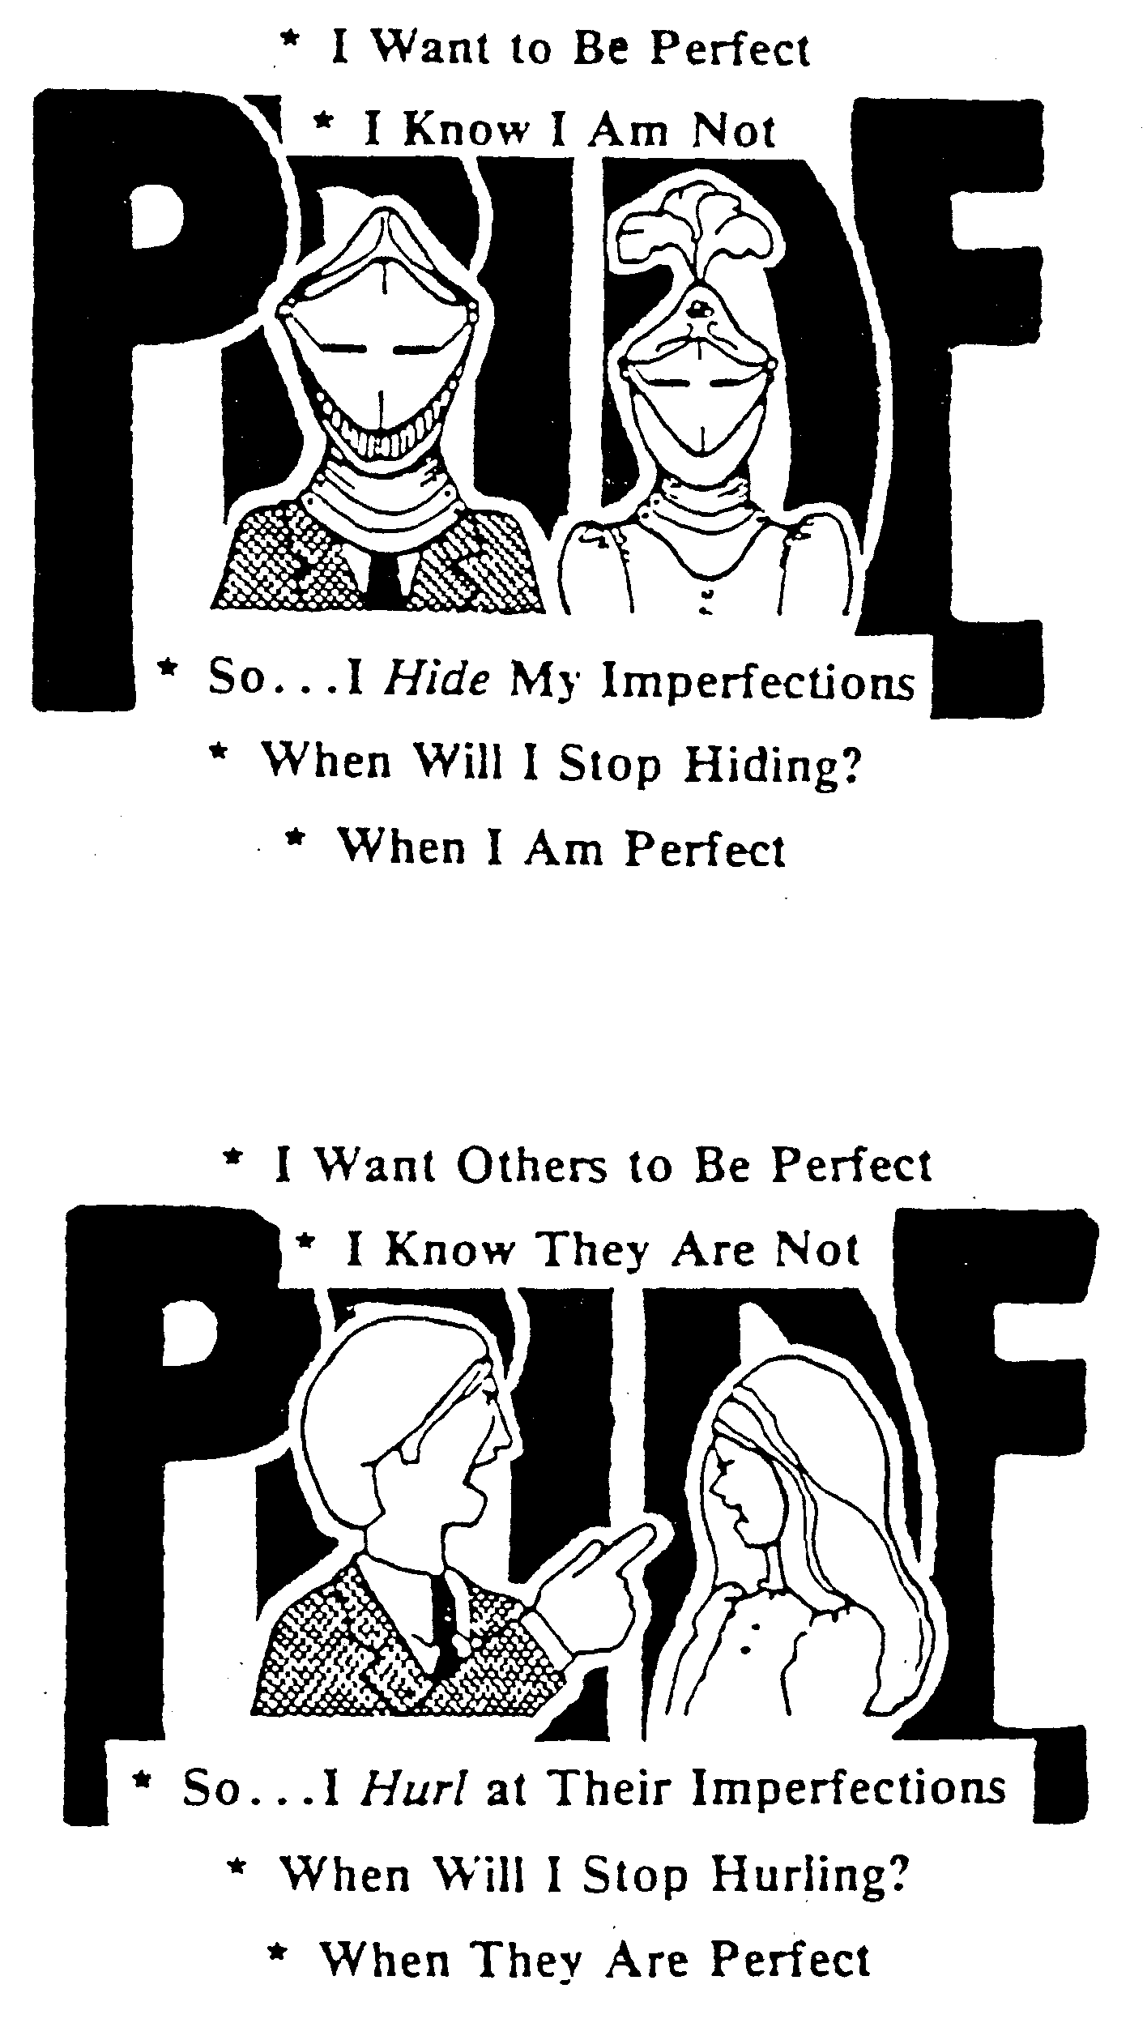
Hiding, Hurling or Helping

Hiding

1. What do I hide?

2. From who do I hide?

3. What happens when I hide?

Hurling

1. When do I hurl?

2. At who do I hurl?

3. What happens when I hurl?

Helping

1. When last did I help someone with helpful words?

2. How did it benefit them and me?

3. What do I need to do to practise helping more?

