Taking Gmail Beyond Email
By Kelly Forrister & Wayne Pepper
Source: http://www.davidco.com/coaches_corner/Kelly_Forrister/article78.html
This guide will show you how to take Gmail™ beyond email, by transforming it into a powerful GTD® action list manager for managing your workflow.
These suggestions will provide the greatest value if you have some familiarity with the David Allen Company workflow mastery model, as outlined in David Allen's book, Getting Things Done - The Art of Stress-Free Productivity.
New definitions of "Label" and "To Do"
Using our method, think of a Gmail Label as a To Do list heading and an email as To Do list item. In GTD terms, these labels will organize your context-based Action lists which hold your “next actions.” By assigning a Label when processing your incoming emails, or using filters on new emails that you send to yourself, you will be putting something on a list.
You will need to setup Labels, Contacts and Filters in a very specific way. This setup will take about 20 minutes. It’s worth it to setup the structure all at once, for at least your Action lists (not necessarily every item at this point) so you’ve got the framework in place.
1. Create Labels
Click on Edit labels and create the following suggested Labels:
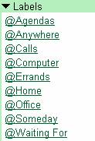
Then create Labels for each of your current projects, or at least a few of them to get started. For example:
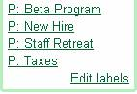
Note, the “@” defines your Action lists and the “P:” defines your Projects to group them together in your Labels window. Any symbol will serve this purpose, these are just suggestions.
2. Create Contacts
Next, create a Contact for each of your new Labels. The purpose of this is to allow you to easily add next actions to your Lists, by sending yourself emails.
Click on Contacts and select Create Contact.
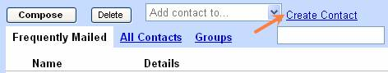
The name field should match closely to the Label name (without the @ or P: code). The Primary Email address will be your email address + a keyword you choose that is similar or the same as the Label name. Gmail has a great feature that recognizes anything added to your email address with a “+” sign as an alias to send to your primary email address. Once we set up Filters in the next step, you’ll see the power of the + feature for quickly and easily filing items onto your various lists.
For example, if my email address is “davidallengtd@gmail.com”, then the Primary email field would list “davidallengtd+agendas@gmail.com”.
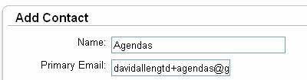
Create a Contact for each of your Action labels (Agendas, Anywhere, Calls, Computer etc.) and any key projects. The end result would look like this:
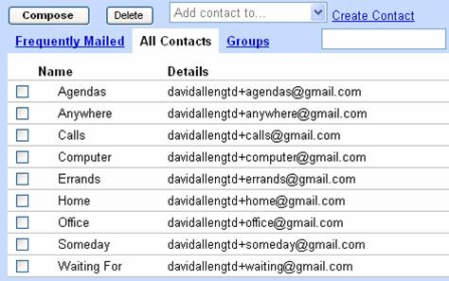
3. Create Filters
Next, create Filters for each of your new Contacts so that you can send action items to one of your lists and have a Label automatically assigned and have it Skip the Inbox (so you don’t have to process it again as a new email).
Click on Settings in the top right hand corner of Gmail.
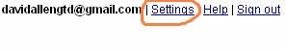
Select the Filters tab, then Create new filter.
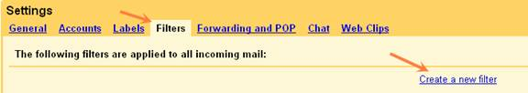
In the “From” field, enter your Gmail email address. In the “To” field, enter the email address you used for each of the Contacts you created for your Action Labels. For example, with Agendas it would be davidallengtd+agendas@gmail.com, like this:
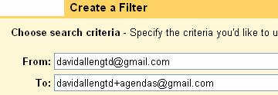
Tips: If you copy your email address the first time, it will make this process go faster with pasting it into each new Filter you set up. The email address in the To: field is not case sensitive (youremail+Calls@gmail.com is the same as youremail+calls@gmail.com), but the name after the + does need to match the Contact name exactly in spelling. If you made the name of the Contact “Calls” then the To: field must be Calls as well, not Call.
Nothing gets added to any other fields on this page. Click on Next Step.
Check off both Skip the Inbox and Apply the label (select @Agendas).
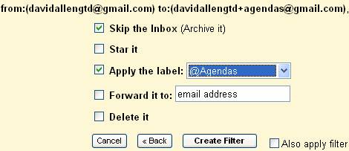
Click Create Filter.
The final structure of Filters will look like this for your Action Labels/Contacts
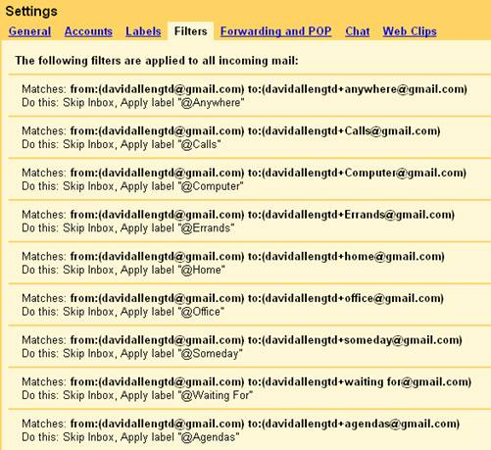
You’re done with the setup.
4. Check it out
Let’s test this out by sending yourself an email and having it automatically sort to one of your new lists.
Click Compose (or C on your keyboard if you’ve got Shortcuts turned on). Type the first few letters of the Contact name for one of your lists, such as Calls.
Gmail should suggest the Calls Contact to you. Press Enter to confirm the match.
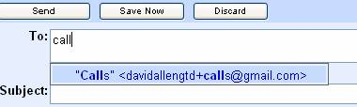
Enter the description for the action in the Subject line:
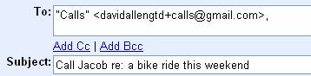
Click Send. Click on your Calls Label and you should see that your email automatically went to that List.
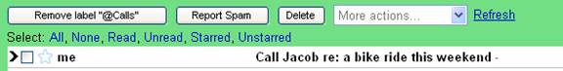
You can also create Filters for each of your Projects, if you choose, or at least your key ones. That way, when you are creating new Actions you can send it to both the Action list and the corresponding Project Labels.
Once you have completed an Action, simply remove the label where it will then be stored in Archive.
Many users also like to have a complete master list of Projects by creating a label called “All Projects” and adding emails assigned to that Label for each Project. Or, you could create a Draft email with the subject as All Projects and update it as your Projects change.
There are many ways to implement David Allen’s GTD methodology. If you would like to check out other Google tools for managing your workflow, try Google Notebook, Google Gadgets and Google Spreadsheets & Documents. Each of these can be powerful list managers if you find ways to make them work effectively for you. The key to GTD is to keep your system simple, accessible and intuitive for you.

