Notes:
__________________________________________________________________________________________________________________________________________________________________________________________________________________________________________________________________________________________________________________________________________________________________________________________________________________________________________________________________________________________________________________________________________________________________________________________________________________________________________________________________________________________________________________________________________________________________________________________________________________________________________________________________________________________________________________________________________________________________
________________________________________________________________________________________________________________________________________________________________________________________________________________________________________________________________________________________________________________________________________________________________________________________________________________________________________________________________________________________________________________________________________________________________________________________________________________________________________________________________________________________________________________________________________________________________________

(7)

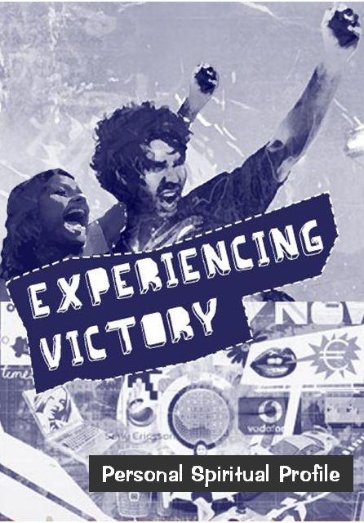
This profile is designed to help you evaluate your spiritual background and upbringing. It is also meant to help you see how wrong patterns of thoughts and behaviour may have developed and become a part of your life. This assessment is between you and the Lord. As a matter of fact, before the last session, these pages will be destroyed, and hopefully the issues you struggled with will be gone as well.
Then I acknowledged my sin to you and did not cover up my iniquity. I said, “I will confess my transgressions to the LORD” – and you forgave the guilt of my sin. Psalm 32:5

I sought the LORD, and he answered me; he delivered me from all my fears. Those who look to him are radiant; their faces are never covered with shame. Psalm 34:4-5

In my anguish I cried to the LORD and he answered by setting me free. Psalm 118:5

Open for me the gates of righteousness; I will enter and give thanks to the LORD. This is the gate of the LORD through which the righteous may enter. I will give you thanks, for you answered me; you have become my salvation. Psalm 118:19-21

Use this space for confidential notes during the sessions:

(1)

 No Problem Past Pattern
Abortion   
Exhibitionism (Stripping/Flashing/Streaking)   
Fantasizing   
Flirting/Seduction/Sexual manipulation   
Premarital Sexual Encounters   
Homosexuality   
Incest (Sex with Family Members)   
Lust   
Masturbation   
Molestation   
Paedophilia (Offender/Victim)   
Pornography   
Prostitution   
Rape   
Bestiality (Sex with animals)   
Voyeurism (Peeping or spying on others)   

Other: __________________________________________________

5. Addictions
Do you not know that your body is a temple of the Holy Spirit, who is in you, whom you have received from God? You are not your own; you were bought at a price. Therefore honour God with you body. 1 Corinthians 6:19-20

Illegal drug use (list all)

Prescription drug abuse (list all)

No Problem Past Pattern
Alcohol   
Computers   
Video Games   
Food   
Gambling   
Nicotine   
Television/Media/Magazines   
Pornography   
Self Mutilation/Cutting or Piercing   

(6)
3. Relational Issues
If you have any encouragement from being united with Christ, if any comfort from his love, if any fellowship with the Spirit, if any tenderness and compassion, then make my joy complete by being like-minded, having the same love, being one in spirit and purpose. Do nothing out of selfish ambition or vain conceit, but in humility consider others better than yourselves. Each of you should look not only to your own interests, but also to the interests of others. Philippians 2:1-4

 No Problem Past Pattern
Anger / Rage   
Argumentative   
Bitterness / Unforgiveness   
Distrust / Suspicion of People   
Serious and Hurtful Breakups   
Envy / Covetousness   
Fear of Rejection   
Gossip / Slander   
Greed   
Hatred   
Jealousy   
Prejudice / Racism   
People Pleasing / Peer Pressure   
Rebellion   
Rejection   
Self-pity   
Unbelief   
Unteachable   
Vengeance   

4. Sexual Sins
The body is not meant for sexual immorality, but for the Lord, and the Lord for the body. By his power God raised the Lord from the dead, and he will raise us also. Do you not know that your bodies are members of Christ himself? Shall I then take the members of Christ and unite them with a prostitute? Never! Do you not know that he who unites himself with a prostitute is one with her in body? For it is said, “The two will become one flesh.” But he who unites himself with the Lord is one with him in spirit. 1 Corinthians 6:13-17

(5)
 Tick the box to the right of each item as it applies to you:

- No Problem: It never was and is not a struggle
- Past: It was a struggle in the past but is not anymore
- Pattern: It is a current or recurring problem

- Generational Curses/Patterns

When all these blessings and curses I have set before you come upon you and you take them to heart wherever the LORD your God disperses you among the nations, and when you and your children return to the LORD your God and obey him with all your heart and with all your soul according to everything I command you today, then the LORD your God will restore your fortunes and have compassion on you and gather you again from all the nations where he has scattered you. Deuteronomy 30:1-3
Generational curses are passed on to individuals due to a pattern of sin in the family which repeats itself in several generations.

Which of the following conditions have affected you or your family in a significant way?
 No Problem Past Pattern
Alcoholism / Drug Abuse   
Barrenness / Infertility   
Business Failure / Lack    Chronic / Lingering / Incurable Diseases   
Emotional or Mental Breakdown   
Failure / Calamity / Disaster / Oppression   
Fear (of Failure, the Future, etc.)   
Hopelessness (Despair, Worry)   
Homosexuality   
Illegitimacy   
Depression, Anxiety Disorders   
Abuse (Sexual, Emotional, Physical)   
Promiscuity or Perversion   
Poverty   
Polygamy   
Premature or Untimely Death   
Repeated Accidents or Disaster   
Sibling rivalry (Generational)   
Suicide / Suicide Attempts (Generational)   
Witchcraft / Sangoma (Generational)   

Other(s):_______________________________________________________________________________________________________________
(2)
Spoken Words: What negative words have been spoken against you by people close to you (parents/teachers/friends, etc?) (e.g. “You’ll never amount to anything! You’re a failure/loser/stupid.” Racial or cultural insults)

Vows: Have you made inner vows to yourself or have you made ungodly pacts with people, organizations, or spiritual forces? Including those relating to traditions, custom, gangs, sects, family or community rituals.

Judgment: What words of condemnation, rejection or judgment have you spoken to others? What have been spoken to you? (e.g. “You are lazy/ugly/ dumb / clumsy.” “Why can’t you be like your sister?”)

2. Spiritual Error
I am the LORD your God, You shall have no other gods before me…. for I, the LORD your God, am a jealous God, punishing the children for the sin of the fathers to the third and fourth generation of those who hate me, but showing love to a thousand generations of those who love me and keep my commandments. Exodus 20:2-6

 No Problem Past Pattern
False Religions
Buddhism   
Eastern Mysticism   
Hinduism   
Islam   
Other(s):   

Cults
Jehovah’s Witness   
Mormonism/Latter Day Saints   
Zionism / Shembe   
Universal Church of the Kingdom of God   
Apostolies   
Branhamites   
Other(s):   

(3)
 No Problem Past Pattern
Idol Worship
Buddhist Idols   
Catholic Saints / Praying to Mary   
Hindu Idols   
Other Idols _________________________   

Unbiblical Covenants
Residence / Dormitory Initiation   
Freemasonry   
Gangs   
Broederbond (or similar)   

False Beliefs
Atheism   
Humanism   
Marxism   
Evolution   
Communism / Capitalism   
New Age (New Spirituality / Self realisation)   
Scientology   
Ancestralism   
Other(s):   

Occult
Astrology / Horoscope   
Fortune Telling   
New Age   
Ouija Board   
Psychic Healing   
Satanism   
Sangomas / Inyangas (Muti/African Rituals)   
Sorcery / Witchcraft   
Spirit Mediums / Divination / Ancestralism   
Spiritism / Amulets   
Voodoo   
Yoga / Transcendental Meditation   
Demonic Video Games   

Other(s):

(4)

